RISK ASSESSMENT FOR: | Use of Bouncy Castle / inflatable’s
Establishment: | Assessment by: | Date:
1st Review Date Due : | Manager Approval: | Date:
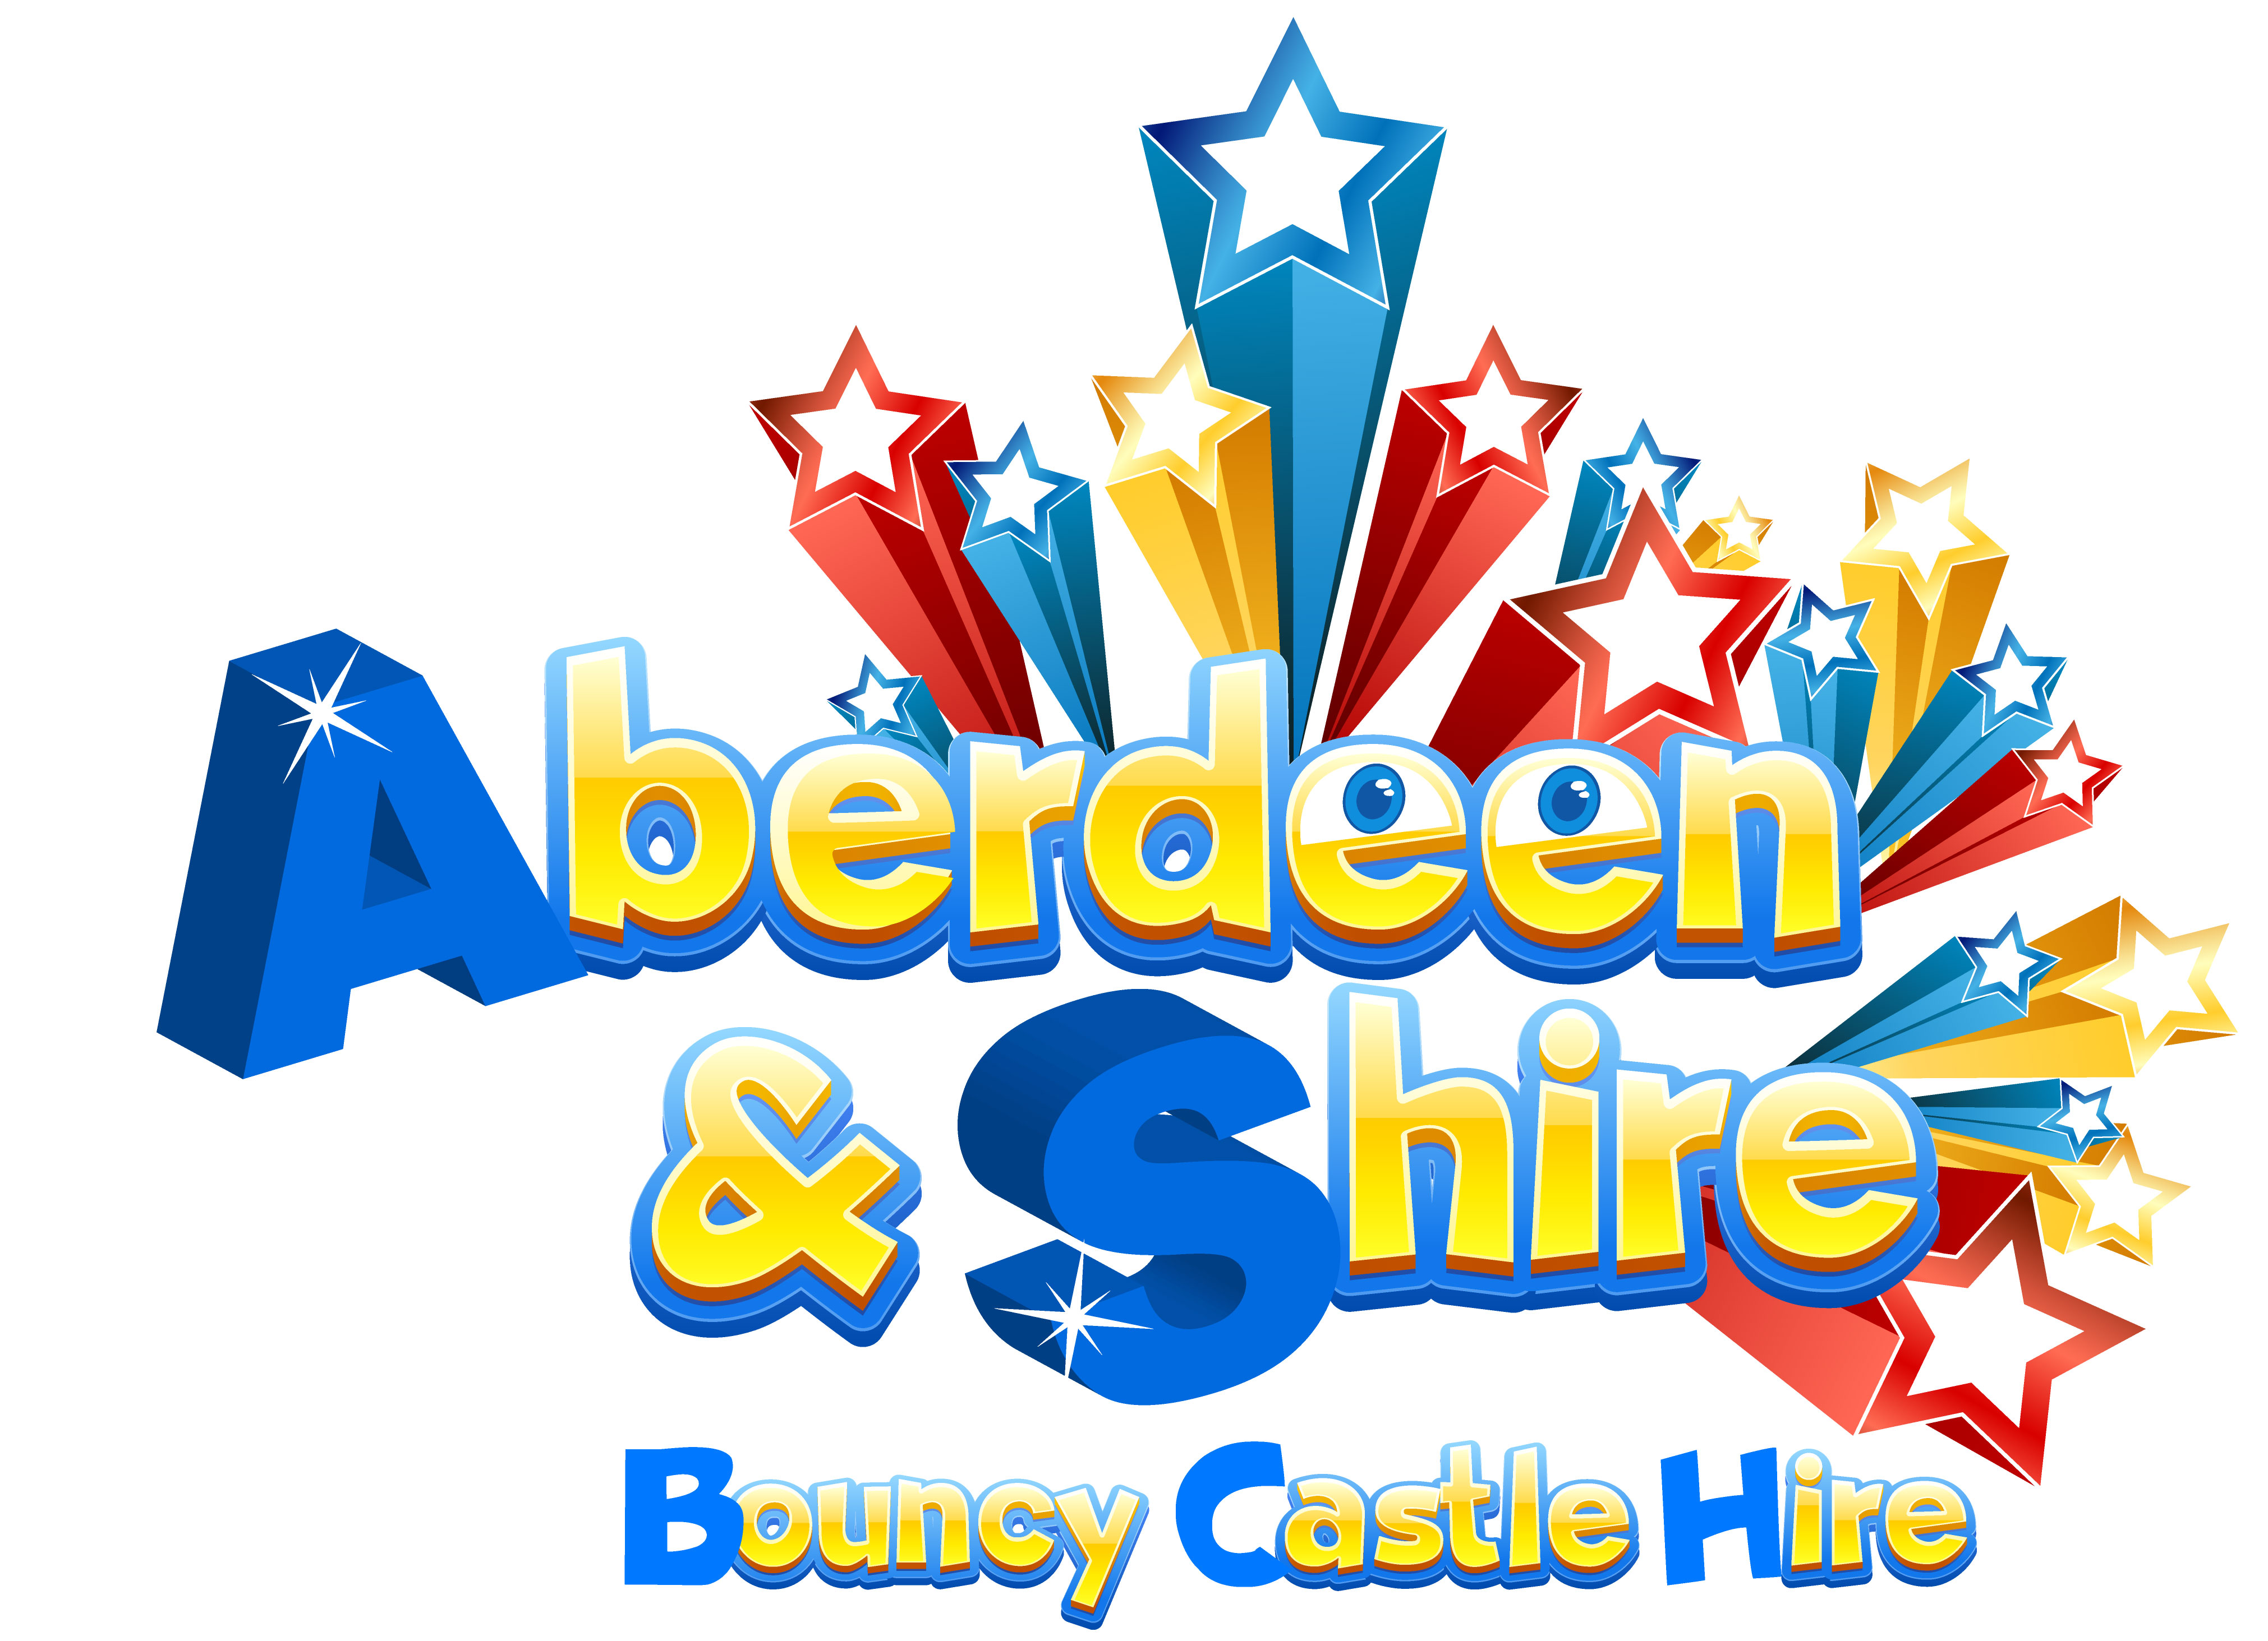

Hazard / Risk | Who is at Risk? | How can the hazards cause harm? | Normal Control Measures | Are Normal Control Measures Y/N/NA
 |  |  |  | In Place | Adequate
Use of external companies / contractors | All Persons | Accidents /property damage might not cover cost of repairs and personal injury claims. | - Operator conforms to BS EN14960-2013 standard  - PIPA / RPII certificates where applicable  - Risk assessments provided  - Appropriate public liability insurance in place ( min £5m indemnity)
Using poorly maintained equipment | All Persons | Electric shock / burns  Cuts / abrasions, broken limbs, muscular skeletal and other physical injuries | - Regular PAT testing of all electric equipment with certificate provided  - Equipment inspected prior to the first use on any day following supplier/ manufacturer’s instructions  - Inflatable has inspection certificate compliant with BS EN14960-2013
Use of specialist equipment  Overloading equipment  Weather conditions  Instability / collapse of bouncy castle  Inadequate supervision  Inappropriate location of equipment | All Persons | Slips /falls  Cuts / abrasions, broken limbs, muscular skeletal and other physical injuries | - Supplied / erected by competent persons.  - Supervision by a responsible adult to prevent unauthorised use and control access and egress.  - Limit on numbers / age / height etc using equipment. (Equipment clearly marked as to its limitations of use).  - Sited in an appropriate location, well away from obstacles such as fences, sufficient room on site for inflatable and blower. (blower is at least 1.2 metres from the inflatable)  - A responsible adult must constantly watch the activities on the equipment.  - A responsible adult must be aware of basic rules for use e.g. all hard/sharp/dangerous objects such as footwear, buckles etc are removed; no bouncing on the front apron of the castle; no climbing or hanging on the outside walls etc.  - Equipment must not be used in winds above 24mph(including gusts)  - All anchorage points must be used at all times. It must not be possible for the equipment to move around.
Manual Handling  Weighty, bulky and unwieldy load  Difficulties in getting a grip of the load  Individuals with pre-existing conditions  Physical Injury – difficult posture  Muscular skeletal disorders  Sprains / strains | All Persons | Slips /falls  Cuts / abrasions, muscular skeletal and other physical injuries | - Sufficient number of people to move inflatable.  - Minimise carrying distance  - Individuals aware of correct lifting techniques

Additional Control Measures  (to take account of local/individual circumstances including changes such as working practices, equipment, staffing levels). | Action by Whom  (list the name of the person/people who have been designated to conduct actions) | Action by When  (set timescales for the completion of the actions – remember to prioritise them) | Action Completed  (record the actual date of completion for each action listed) | Residual Risk Rating
DATE OF REVIEW:  Record actual date of review | COMMENTS:  Record any comments reviewer wishes to make. Including recommendations for future reviews.
DATE OF  REVIEW: | COMMENTS:
DATE OF  REVIEW: | COMMENTS:

RESIDUAL RISK RATING | ACTION REQUIRED
VERY HIGH (VH) Strong likelihood of fatality / serious injury occurring | The activity must not take place at all.  You must identify further controls to reduce the risk rating.
HIGH (H) Possibility of fatality/serious injury occurring | You must identify further controls to reduce the risk rating.  Seek further advice,
MEDIUM (M) Possibility of significant injury or over 3 day absence occurring | If it is not possible to lower risk further, you will need to consider the risk against the benefit. Monitor risk assessments at this rating more regularly and closely.
LOW (L) Possibility of minor injury only | No further action required.

