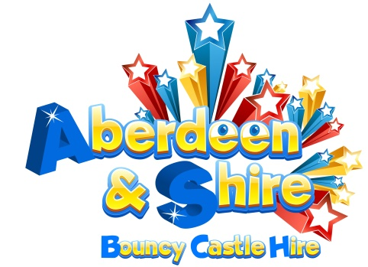

**Method Statement – All inflatables.**

**1. Upon arrival, the driver will take note of any safety information or displays and adhere to the rules of the site at all times.**

**2. The driver will ensure that whilst the vehicle is on a designated carriageway or road surface, the rules of that specific highway are bided by at all times.**

**3. Should the vehicle be required to travel on any undesignated areas, such as verges or footways, the vehicle will travel at a maximum of 10 miles per hour with the hazard lights flashing at all times. In these specific areas and/or other highly populated areas, the use of a banksperson is recommended but not compulsory.**

**4. The area will then be inspected for suitability, at which time, any large stones or sharp objects will be removed & disposed of in a safe manner.**

**5. The area will then be checked for suitable height & for any obstructions. e.g cables, trees, lights.**

**6. The inflatable will then be laid out & unfolded into place, a ground sheet may be used at this point where necessary. The cables will be laid out and connected to electric as agreed prior to our arrival.**

**7. The inflation device will then be checked, connected & switched on ensuring all vents are unobstructed, bent or twisted. The remaining vents on the inflatable will then be secured.**

**8. The unit will now be inflated, ensuring that no one is on or near the inflatable.**

**9. Then the various anchor points pegged in place using 16mm x 380mm steel anchor steaks at various points. NOTE* All anchor points require fixing when inflatable is sited outdoors, inflatables cannot be used in windy conditions where gusts are 24mph or above.**

**10. When erecting on indoors on a hard surface, weights or sand bags may be used**

**11. It is imperative that guests or other persons involved in the event do not encroach on the set up area unless specifically requested to do so. NOTE* All equipment to be erected as per manufacturers Health & Safety guidelines & under no circumstances can this be compromised in any way, regardless of aesthetics or the discretion of the venue/organisers.**

**12. Where necessary barrier fencing, rope or tape to be used to cordon areas of especially on public events.**

**13. Once the inflatable(s) have been checked over by the event manager or delegated health & safety officer, the event may begin.**

**14. Upon completion of the event, the inflatable must be evacuated & an allocated member of staff will ensure that no participants are left on the item whilst deflation is in progress.**

**15. Once deflation had completed, all anchor pegs, cables & blowers will be removed from site & placed back into the collection vehicles.**

**16. The inflatable will then be folded & rolled in an acceptable manor & transported to the vehicle, either by sack truck or wheel cart. When dealing with larger items, the collection vehicle may be required to drive to individual items for collection. Again, the vehicle will travel at a maximum of 10 miles per hour with the hazard lights flashing at all times. In these specific areas and/or other highly populated areas, the use of a banks person is recommended but not compulsory & the rules of the site will be observed at all time.**

**17. The area will then be checked for debris & other accessories, which will be dealt with accordingly.**

**18. The delivery vehicle will then depart the site, in a similar manor to that described above, again taking note of any instructions given or signing in place**

